**Anamorphism**

Yelick S., *Anamorphic Image Processing*, MIT BS. thesis:

Linear perspectives: 1-point, 2-point, 3-point

“Two point perspective allows an object to be viewed from any horizontal angle.” (p.10)

“Three point perspective gives full freedom of viewing angle.” (p. 10)

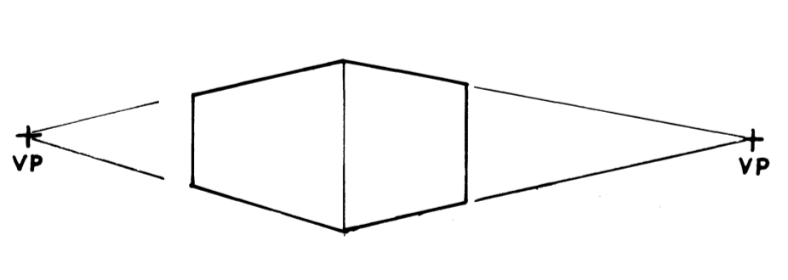 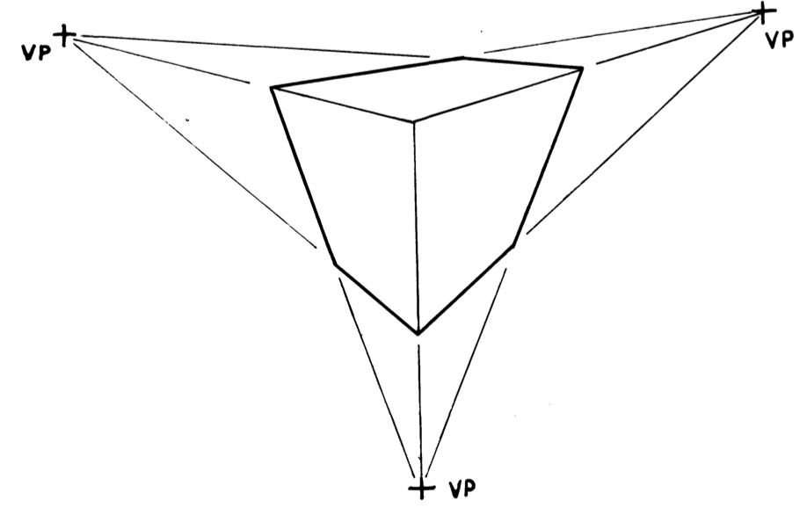

-> Using “more-point” perspectives so that the image can be viewed from more angles? – for multiple observers?

Interpolated views: e.g. projecting on two walls that are at an angle (corner of a room)

* Projecting on non-flat surfaces, e.g. wall in the RKC

Cylindrical anamorphisms:

<http://www.ac-grenoble.fr/maths/LAB/espace/pages/anamorph43.htm>

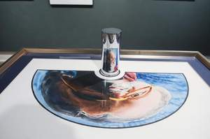

Conical anamorphisms:

<http://www.anamorphosis.com/stenope.html>

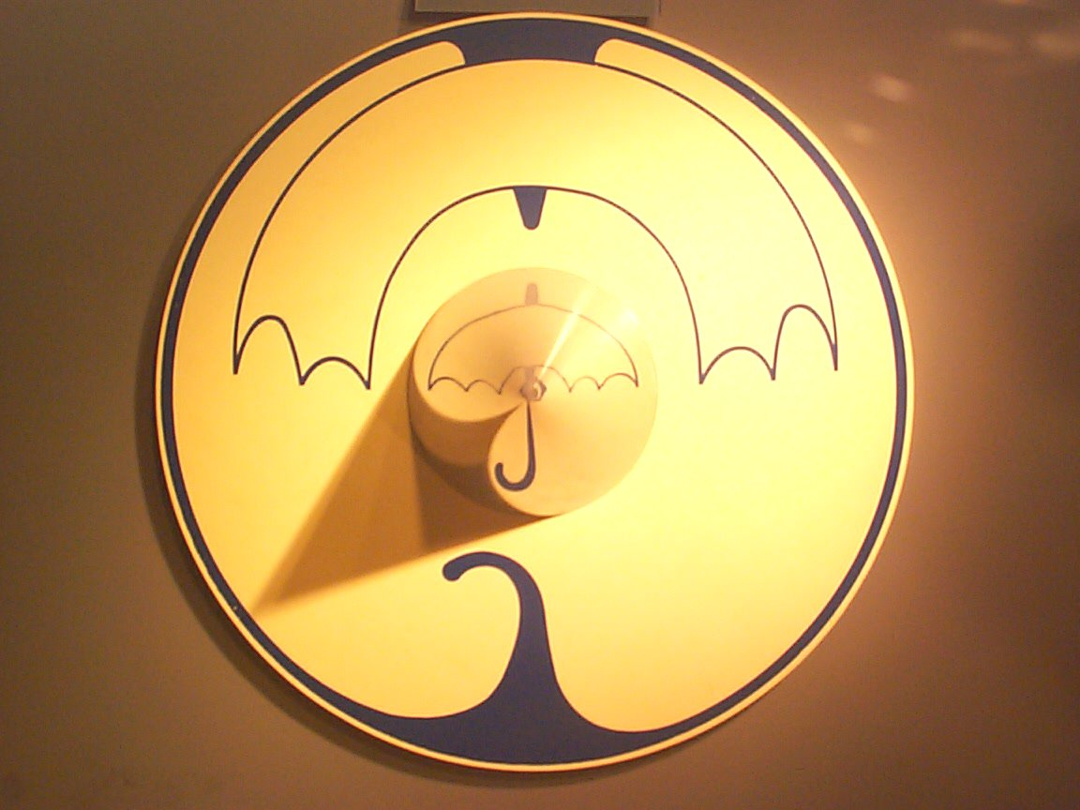

Anamorphic sculptures for cylindrical mirror:

<http://www.edotmagazine.com/anamorphic-sculpture-by-jonty-hurwitz>

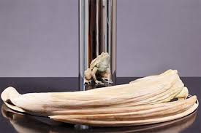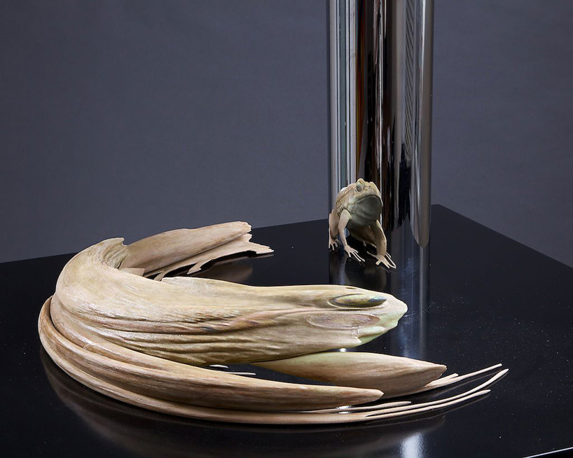

talk Jim

send paper to keith

sources for papers:

- acm

- ieee